INSTALLATION OF PYTHON 3.9.8

|  |  |
| --- | --- |
|  |  |
| Team ID | PNT2022TMID28961 |
| Project Name | Gas leakage monitoring and alerting system for  industries |

Step 1: Type python in google and click on the first link



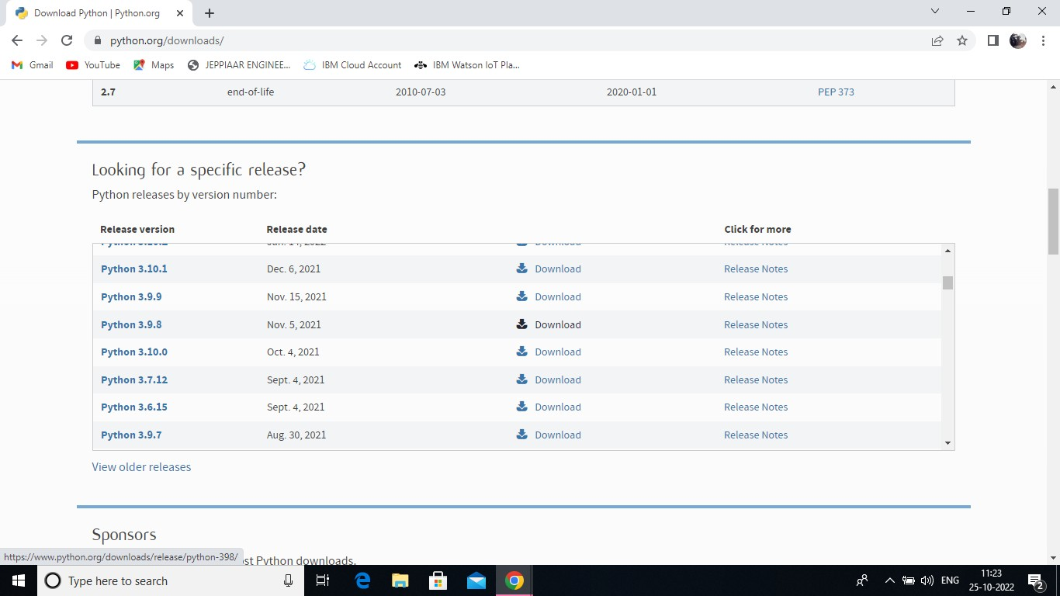

Step 3: Scroll down to reach Files and click on “Window installer (64 bit)

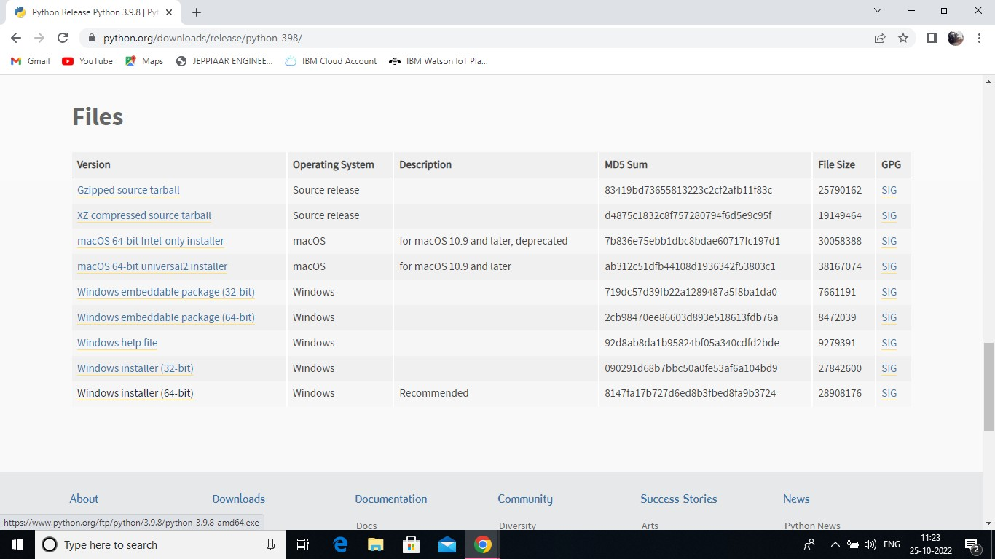

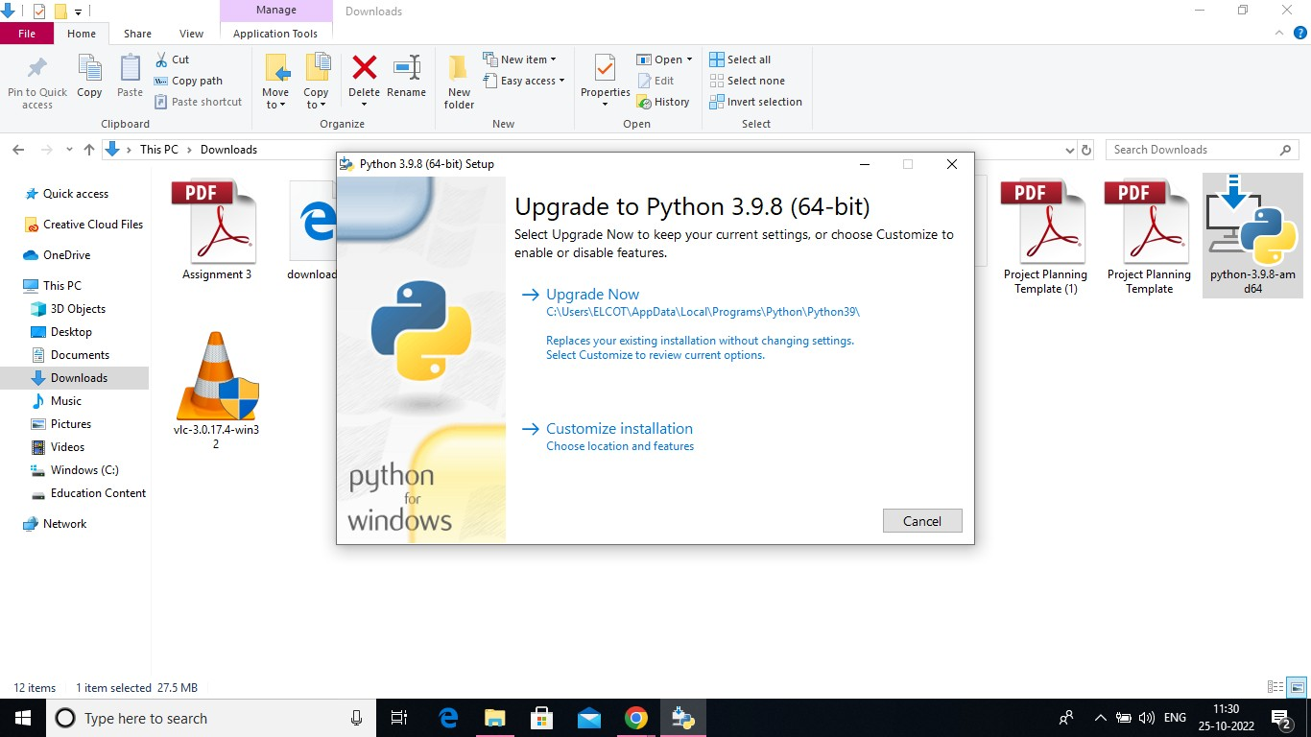

Step 5: Installation on progress

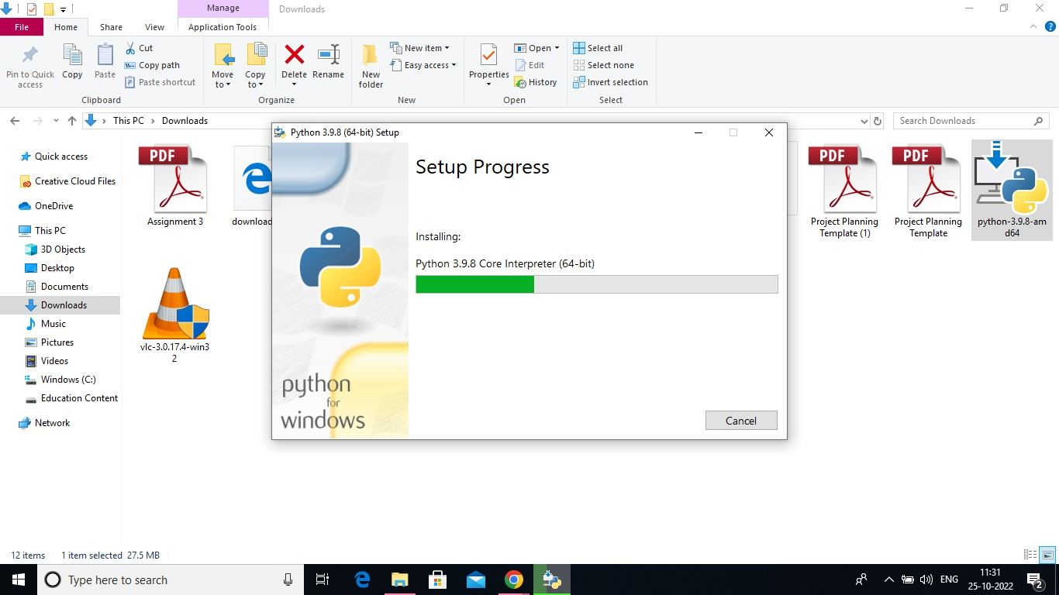

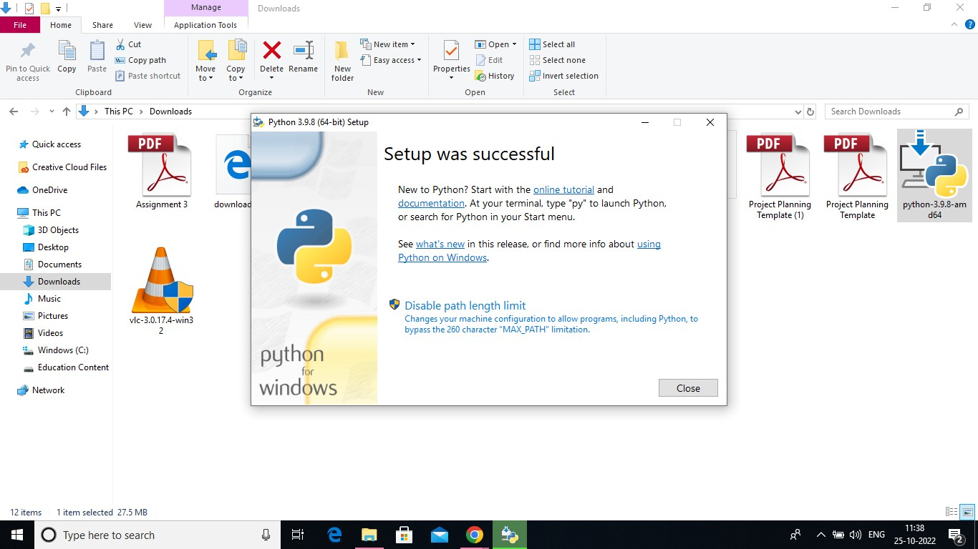

Step 7: Search IDLE

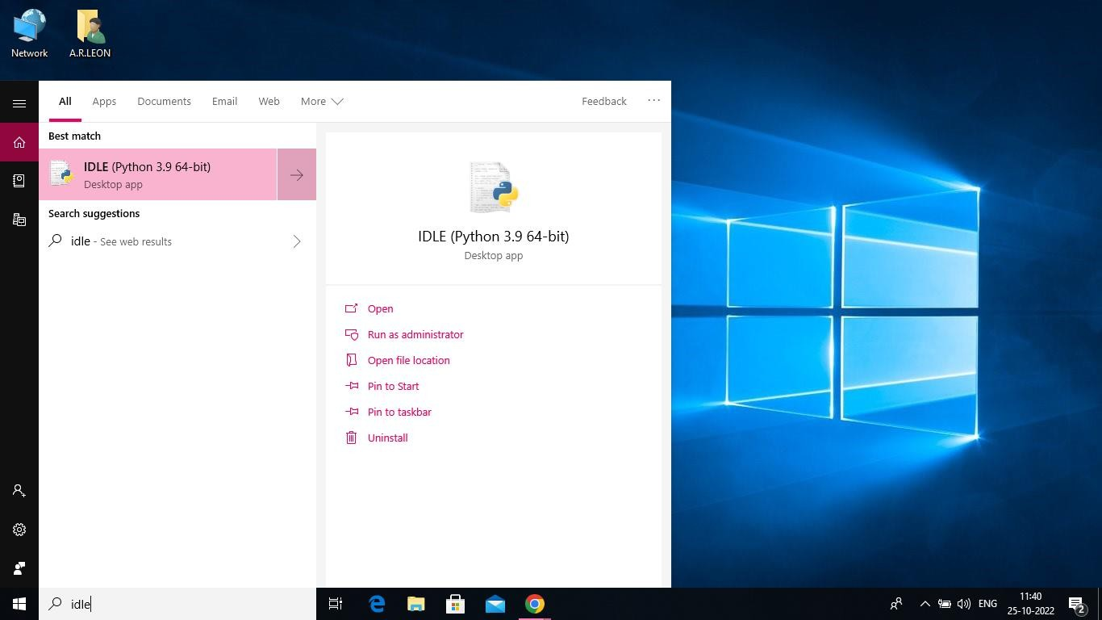

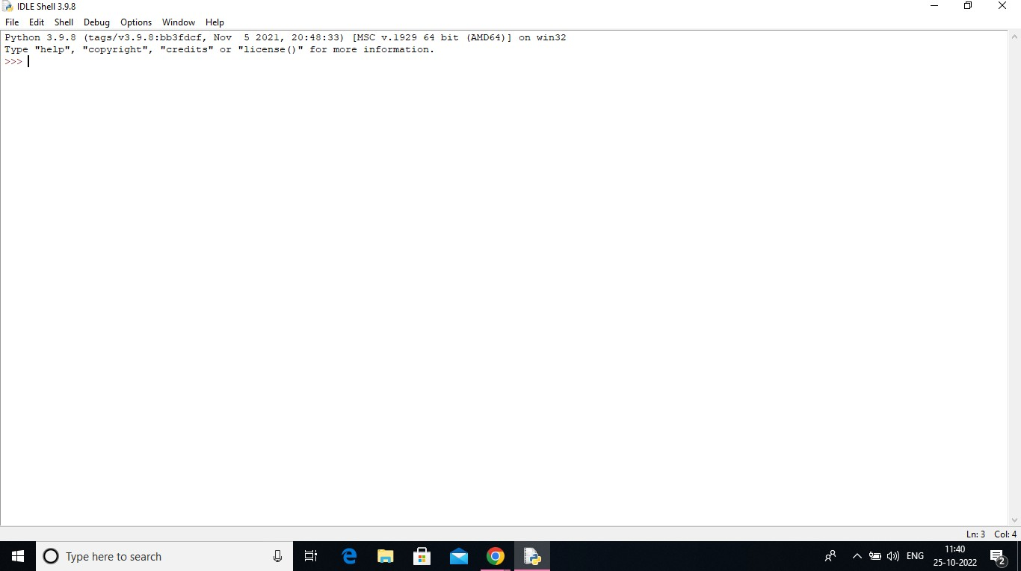

Step 9: Go to file and click on New File

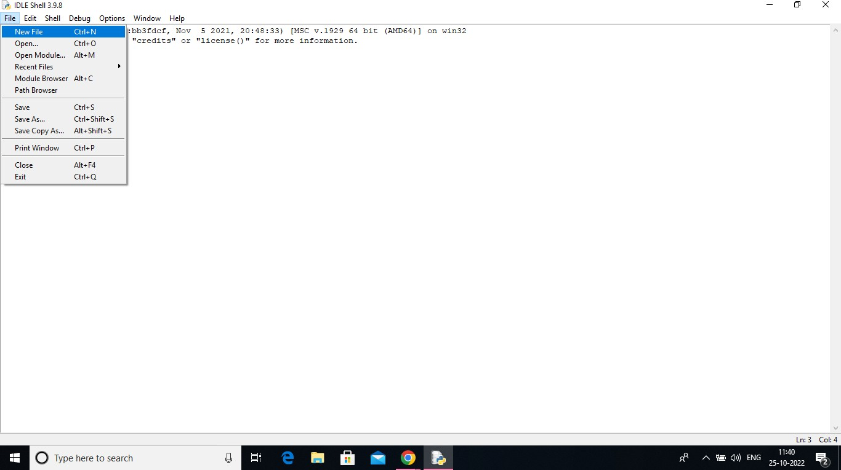

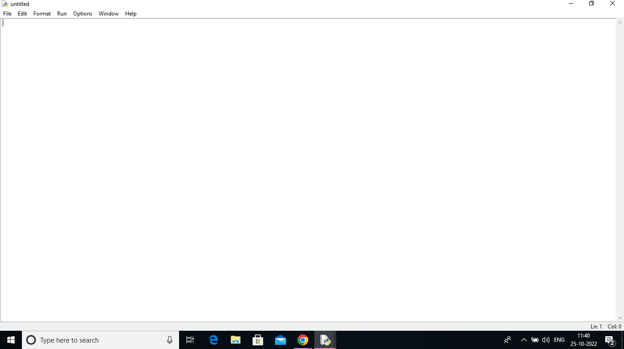

**Result:**

A Python 3.9.8 is installed successfully.